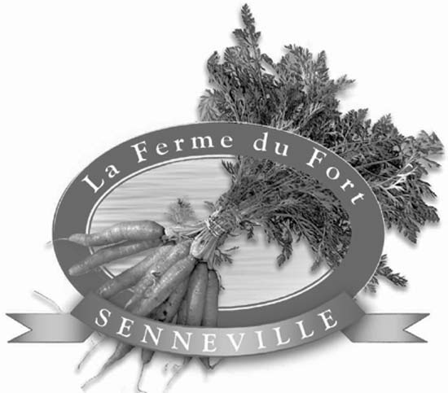

La Ferme has been run by Alison Hackney since 1996 on land owned by her family for over 100 years. Her produce has been certified by Garantie Bio since 2002 which means no pesticides, herbicides, or synthetic fertilizers are used.

Community Supported Agriculture (CSA) is a partnership between consumers and farmers in which the benefits and risks of farming are shared. In return for purchasing the CSA box in advance, the consumer receives fresh, local, organic produce all season long, while the farmer knows in advance how much she needs to grow. Participating members pay ahead for a share of the season’s vegetable harvest and their box is picked up weekly at La Ferme. Members are also invited to participate in farm activities, such as garlic braiding and our harvest party.

- Cost for a share July 5, 2006 to November 8, 2006: $515 – ($15 goes to support Equiterre's CSA farm network)
- .

Information & registration

Thursday - March 9, 2006 - 7:30 pm
Harpell Centre
60, St-Pierre, Ste-Anne-de-Bellevue

For additional information about the CSA program or to visit La Ferme, please contact Alison Hackney at:

Tel: (514) 457-3606
E-mail: alison.hackney@sympatico.ca

or visit our website at
www.lafermedufortsenneville.com

List of vegetables

arugula | leeks
beans | lettuce
beets | peppers
broccoli | oignons
brussels sprouts | oriental vegetables
cabbage | parsley
carrots | peas
cauliflower | radish
celeriac | rutabaga
cherry tomatoes | summer squash
cucumber | swiss chard
eggplants | spinach
fennel | tomatoes
fresh herbs | winter squash
garlic

Other products not produced on our farm are available for sale (potatoes, melons, poultry, etc).

* Generally a share is enough for a family of 2 adults and 2 children.

Some examples of a weekly "share"*

- Early July: 1 cauliflower, 1 savoy cabbage, ¼ kg spinach, ½ kg peas, ¼ bag salad greens, 1 bunch radishes, 1 bunch green onions, parsley, basil.
- August: 3 onions, 1 kg tomatoes, 2 peppers, ¼ salad greens, 1 eggplant, 3 cucumbers, cherry tomatoes, 2 lb carrots, 2 zucchinis, ½ kg beans, garlic.
- October: 1 kg Brussels sprouts, 1 bunch beets, 1 broccoli, 1 bunch leeks, 1 bunch radishes, 1 bunch pack choi1 cabbage, ¼ kg arugula, 1 rutabaga, 1 celery root, parsley, 1 cucumber, 1 winter squash.

* Examples only -- Quantities may vary.

Extra produce for pickling or freezing is available. Call for pricing.

Sign-up Form

As a member of La Ferme du Fort Senneville's CSA program, I will pick up* my vegetables on the date and time specified. I understand that weather and animal pests may affect crop yields, and I accept the risk.

Name:
Address:
Town/postal code:
Telephone:
E-mail:
signature

- I authorize La Ferme to give my coordinates to Équiterre—who will not forward it to other organizations. In doing so, I will be updated on all Équiterre’s activities.

- I'd like to help in exchange for a credit towards my 2007 basket by preparing vegetables, communicating with other members, or organizing farm activities.

Please make your cheque for $515 to the order of La Ferme du Fort Senneville or pay with post-dated cheques: $215 on sign-up date; plus 2 of $150, dated May 1st, 2006 and June 1st, 2006. Send cheques to:

Alison Hackney
118 Senneville
Senneville, Quebec H9X 1B9

Please bring your own bags for your vegetables (we will provide plastic bags but at a nominal fee). We also have recycled cotton bags with the Equiterre logo for sale. Also, please note that there is one pickup day, Wednesday, and it is your responsibility to pickup your share at the farm. If you can’t make it, we suggest that you have a friend or neighbour pick it up or call us (cell phone 514-885-4866) in advance and ask us to leave it out for you or to leave it in the cold room for pickup on Saturday. Unless you make other arrangements with us, unclaimed vegetable shares will be donated to a local food bank.

Thank you & Hope to see you soon!

